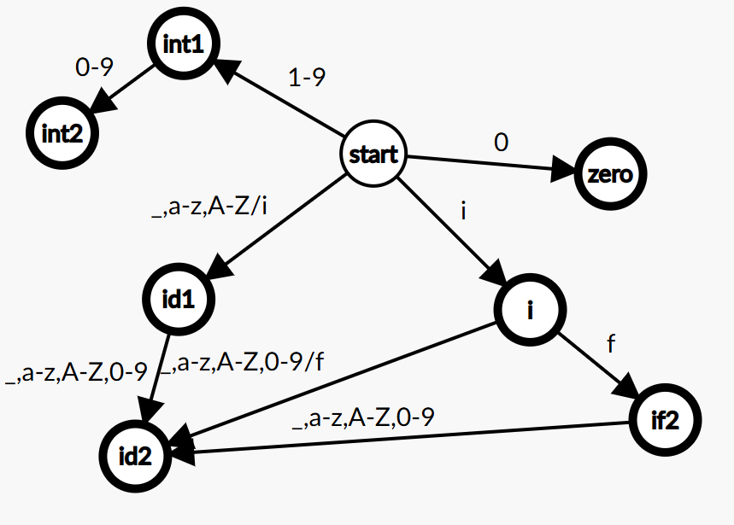
DFA for IF | INT | ID
Id2 has loop _,a-z,A-Z,0-9
Int2 has loop 0-9

List of transitions:
start id1 _,a-z,A-Z/i (excluding i)
start int1 1-9
start zero 0
id1 id2 _,a-z,A-Z,0-9
id2 id2 _,a-z,A-Z,0-9
int1 int2 0-9
int2 int2 0-9
start i i
i id2 _,a-z,A-Z,0-9/f (excluding f)
i if2 f
if2 id2 _,a-z,A-Z,0-9

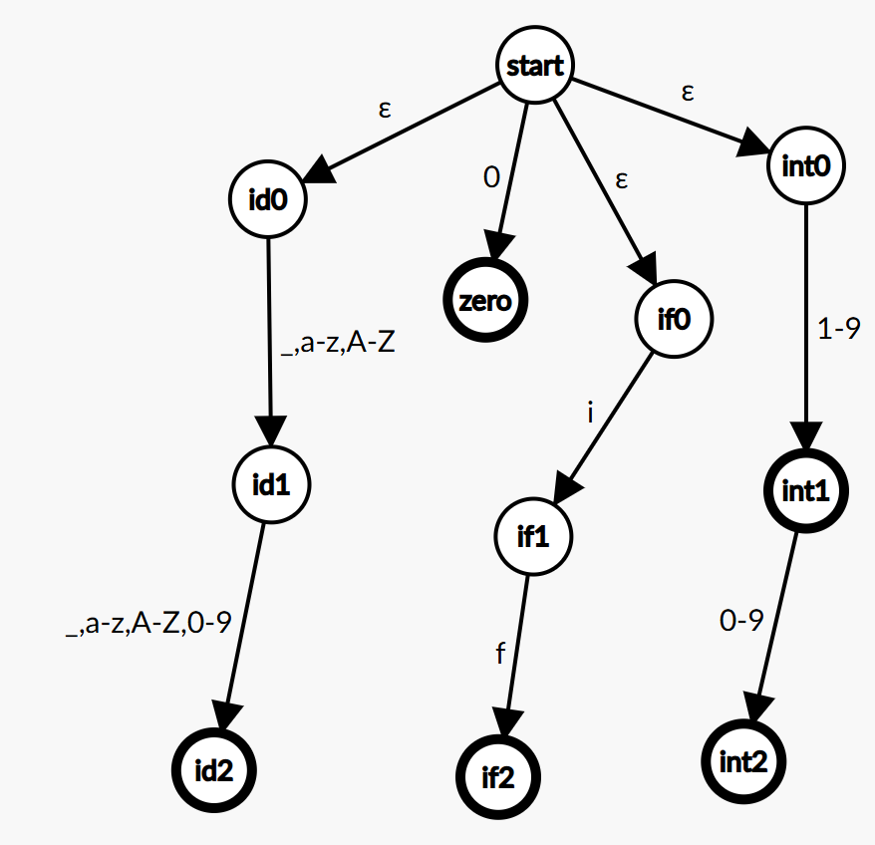
NFA for IF | INT | ID

Id2 has loop _,a-z,A-Z,0-9
Int2 has loop 0-9

List of transitions:
start id0 ε
start if0 ε
start int0 ε
start zero 0
id0 id1 _,a-z,A-Z
id1 id2 _,a-z,A-Z,0-9
id2 id2 _,a-z,A-Z,0-9
if0 if1 i
if1 if2 f
int0 int1 1-9
int1 int2 0-9
int2 int2 0-9

